Giving a Persuasive Speech
Just because the colonists were upset about the way Britain was treating them did not mean that they all wanted independence. Some were uneasy about the likelihood of success. Others hoped for a reconciliation. Some even thought the British were right!

To help gain support, a number of men and women stood up and spoke on the importance of independence, of being free from domination by a far-away British government, and of liberty and individual rights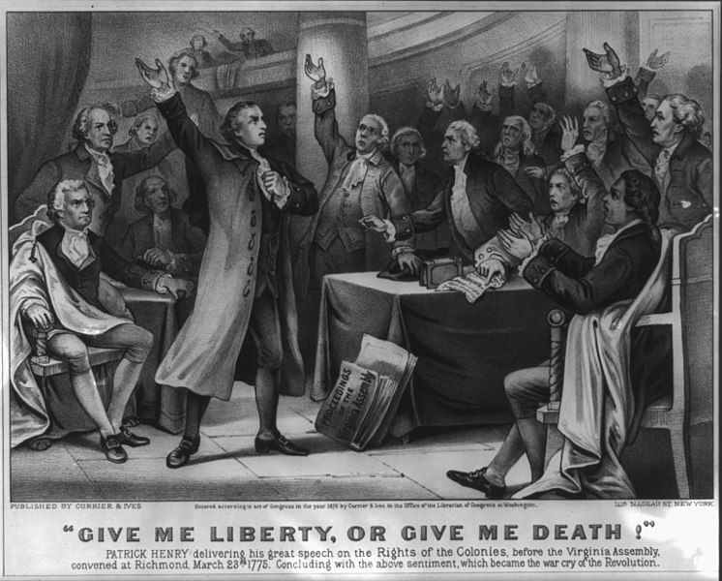

Some of these speeches were given in the streets, some in the pubs, and others during meetings. Some were impromptu, and others were planned. Some endured and inspired, and others were… well… easily forgotten.

An effective, inspiring, enduring speech is one that hits home with the audience and speaks to them.

Crafting an effective speech requires some planning.
.
Image compliments of ​Wikimedia Commons​.

First,​ you need a topic. For this assignment, you are going to give a persuasive speech encouraging your fellow colonists to support the colonies’ quest for self-government and endorse the Declaration of Independence. (Alternatively, they can argue against it, and to remain a part of the British empire.)

Second,​ you need to consider your audience. Who are they and what do they want to hear? What would convince them to agree with you? There are three ways to reach the audience and get their attention. You can use:
- Ethos ​-- this means that you talk about what is morally or ethically right.
  - A speaker supporting independence might bring up the fact that denying the colonies representation is neither moral nor ethical.
- Logos ​-- this means that you look at logic.
  - A speaker for independence might point out that a lack of representation means that there is no one to defend the colonies, which leaves them vulnerable to exploitation.
- Pathos ​-- this means that you aim for emotions.
  - A speaker against independence might use guilt and argue that those who seek independence are turning their backs on their ancestors who fought to make England what it is today.
Ideally, you will use a combination of all three. You want to use emotion to pull them in, but you want to use logic and ethics to keep their attention. At no point, though, should you resort to calling names, insulting, or otherwise bashing the other side. Stick with ethos ​and ​logos​ to make your points.

Third,​ you want to draft your outline. One approach is to follow the “Attention-Argument-Counter-Action” (AACA) approach.
- Attention -- get the audience’s attention
- Argument -- present your argument
- Counter -- address the counterargument
- Action -- call the audience to action
A credible argument always makes it a point to discuss the counterpoints and explain why they are ineffective. You can use the provided worksheet to create your draft.

Fourth​, you need to edit. Review your speech and make sure that you are clear and concise. Say what needs to be said and then stop.

Fifth,​ you have to practice. This will help you deliver your speech with confidence, which is absolutely vital if you want people to agree with you.

